Story Beats

Garrett Huxtable

January 18, 2016

GAT 399 Spring 2016

Boyan Radakovich

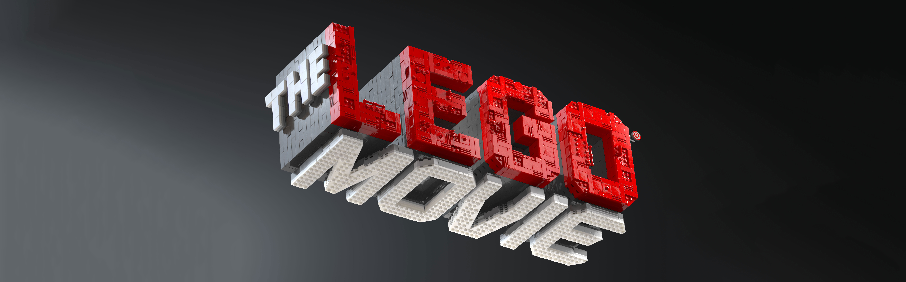

**Story Beats in *The LEGO Movie***

With *The LEGO Movie* clocking in at 92 minutes without credits, it follows the basic child film structure of being approximately and hour and a half, but how does it stack up against the story beats we covered in class? Overall, pretty well. However, the movie throws in a fake plan sequence between the fall and death, which will be covered later. As for the timing of the beats, *The LEGO Movie* starts out sticking to the times we established almost on the dot, but loosens its grip ever so slightly in the second act before returning to form in the third act.

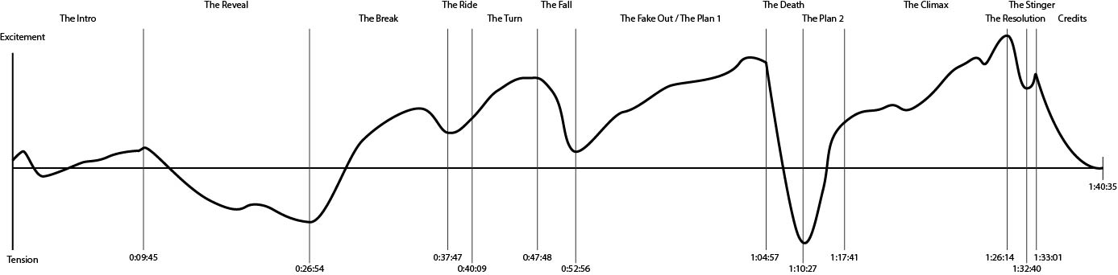

**The Intro** (0:00:25 – 0:09:45)

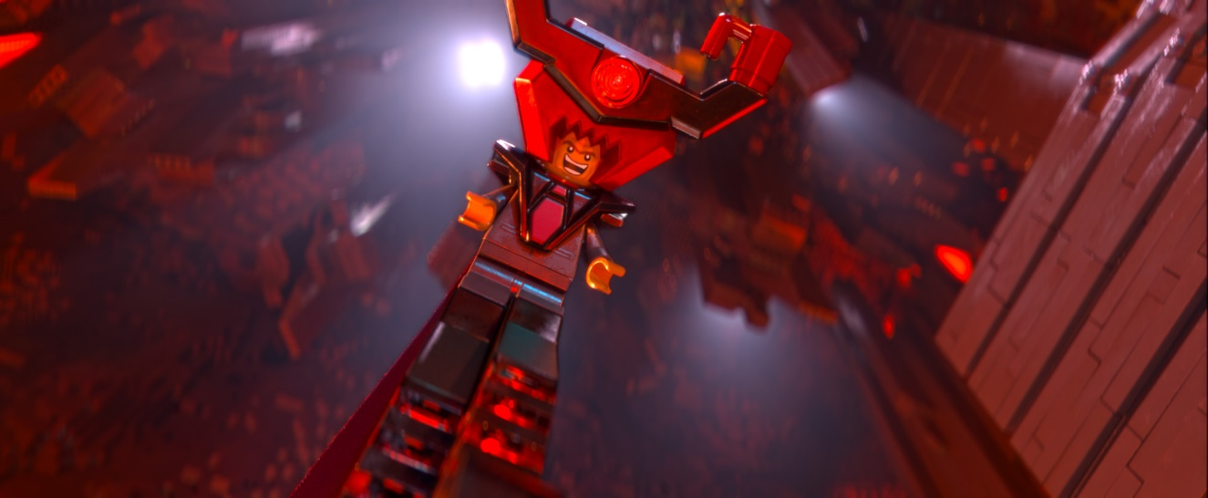The intro to *The Lego Movie* is comprised of two scenes. The first scene acts as a prologue and serves to introduce the viewer to the primary antagonist, and one of the main supporting characters. It is at this time that we establish that Lord Business is evil, and Vitruvius is good. Even before Lord Business speaks, the audience can guess that he is a villain, he is draped in red and black, and the lighting on him is a crimson red. By comparison, Vitruvius, is covered in white, and reveals a prophecy which spells the end of Lord Business’ reign of terror.

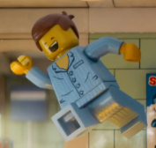 The second scene occurs eight and a half years later, and introduces the audience to their protagonist, and the world in which he lives. We watch as Emmet starts his day, grabs a cup of morning, coffee, and goes to work. This scene establishes Emmet as a friendly guy who knows his neighbors well and seems exceptionally chipper all of the time. However, it also serves to hint at the larger threat which Emmet is about to face. It is during this scene that we first see Lord Business as President Business, and establish that he has near complete control over Emmet and every other person in the world. This scene utilizes warm colors in soft tones to engender the viewer to Emmet and the world. The closer the move gets to the reveal, the darker the shots become. By the time Emmet meets Wild Style, the film has literally shifted from day to night. The intro ends with Emmet discovering the films McGuffin, The Piece of Resistance, and falling asleep.

**Does it Work?**

The intro absolutely nails everything. The starts with a brief excitement spike before quickly dipping into tension as the villain succeeds in the first phase of his plan. The excitement then slowly rises as the protagonist is introduced and the world is expanded upon. It is a slow build of excitement, but as everything is new and novel, the excitement does continue an upward trend until the end of the intro. There is a very brief spike at the end of the intro which is where the protagonist discovers the McGuffin, and has his path set into motion, even if he has yet to actually receive the call to action.

**The Reveal** (0:09:46 – 0:26:54)

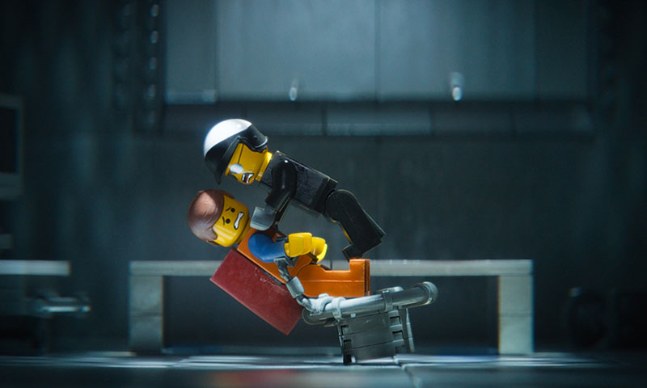 The reveal begins with Emmet being interrogated by the films supporting villain, Bad Cop. During the entire course of the reveal, the audience, and to a lesser degree Emmet, is made aware of the plans of both Lord Business and the resistance.

It all begins with Bad Cop’s interrogation. During this scene, it is revealed to Emmet that Lord Business plans on “destroying“ the world on Taco Tuesday, and that everyone who he cares about views him as a nobody. The destruction of his self-schema is the only reveal that truly sticks with Emmet as this time. After being sentenced to death, Wild Style saves Emmet and continues to convey important information to him throughout the entirety of the ensuing chase. None of this information truly sticks to Emmet during the scene, and it is revealed to the audience that Emmet might not be so cut out for being a hero. After the chase ends, Wild Style is disillusioned with Emmet, but proceeds to fill him, and the audience in, on exactly what has transpired in the years since the prologue.

Just before the break, there is yet another important reveal scene. It is at this time, that Lord Business, reveals his master plan, in all of its detail to Bad Cop and the audience. To cap off the reveal, there is the first “death” of the film when Lord Business wipes away the Good Cop side of Bad Cop before having him glue his own parents in place.

**Does it Work?**

While there are moments of excitement in the reveal, overall it is a downward trend into tension. The tension begins immediately with the interrogation and subsequent breaking of the protagonist. It is then followed by the threat of death, before briefly being raised by a rescue sequence leading into a tension laden chase which culminates in the protagonist becoming broken again. To cap it off, the death of Good Cop and the reveal of the villains plan serve as a final tension punch before the break begins to build the excitement back up again.

**The Break** (0:26:55 – 0:37:47)

During the break, we see Emmet built up again after being torn down several times throughout the reveal. It is here that Emmet receives his call to action and officially joins the resistance. He and Wild Style meet up with Vitruvius who acts as a mentor figure to Emmet, promising to guide him on his path to becoming a master builder. Shortly after their meeting, they are interrupted by Bad Cop and another chase ensues.

During this chase, Emmet is challenged to utilize his creativity and fails spectacularly at first. With more encouragement, and some quick thinking, Emmet begins his journey towards his goal as he eventually comes up with a useful idea. Near the end of this chase the characters are introduced to Batman, and he aids them in their escape.

**Does it Work?**

 The break is the last part of *The LEGO Movie* that sticks to convention until the plan 2 gets things back on track. After the breaking of the protagonist’s spirit in the reveal, the break serves as a place where he is built back up and allowed to prove himself for the first time. The chase scene also serves to add to the excitement level after the world building and conflict introduction of the reveal has brought the tension to its lowest point yet. The break ends with the character moving on to their next location, and nothing having truly changed with the status quo.

**The Ride** (0:37:48 – 0:40:09)

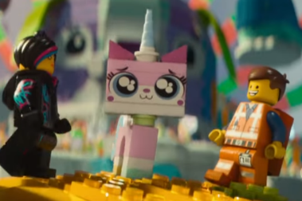As the ride begins, Emmet and his allies are riding in the batmobile. There is a brief expansion of the universe via the characters driving through Middle Zealand on their way to Cloud Cuckoo Land. Upon arriving in Cloud Cuckoo Land, the characters meet Unikitty. She serves as their guide and leads them to the meeting hall where the turn will begin.

**Does it Work?**

The ride is where the movie falters and strays from convention. While it serves the same purpose as a typical ride, it is far shorter than the average. The ride is shortened to make room for the two plan sequences within the film and exists purely to get the characters from the break to the turn.

**The Turn** (0:40:10 – 0:47:48)

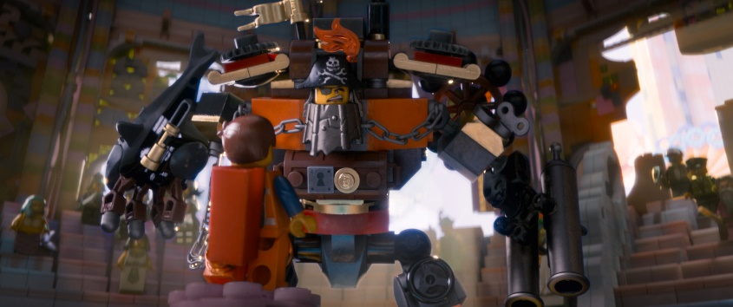The turn starts with Emmet delivering a speech to the master builders which fails to excite. It is also at this time that we are introduced to our final two compatriots, Metal Beard and Benny. Emmet’s speech not only fails to rally the master builders, but actually leads to several of them seemingly abandoning the cause. The meeting is quickly broken up by Bad Cop and the master builders begin a fight for their freedom.

**Does it Work?**

 The turn manages to maintain the same length as in a typical film, but serves as only the first turn. There is a second turn which occurs during the fake plan sequence. This turn covers exactly what it should, allowing the protagonist a moment in the spotlight before ripping them down and leading into the fall. It is only at a moment when the protagonist rises to their greatest, that the fall can be the most impactful, and in that way it fails. While Emmet is certainly at his greatest thus far, he has not yet achieved anything significant, nor made any large strides towards his goal of becoming a master builder. While this reduces the impact of the fall, it increases the impact of the false plan.

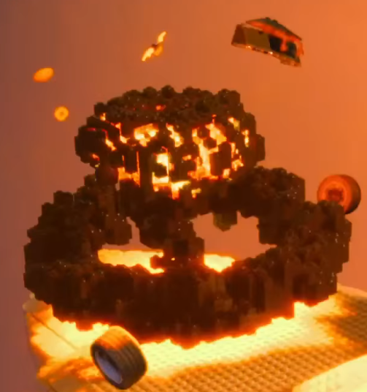**The Fall** (0:47:49 – 0:52:56)

The fall occurs during the attack on Cloud Cuckoo Land and immediately afterword. First, the master builders are quickly defeated by Bad Cop and his forces. Then, Cloud Cuckoo Land is completely destroyed. Finally, despite escaping, the main characters sub explodes and they are left without a means of travel in the middle of the ocean. While brief, it serves as a time in which the heroes are scene failing at every turn, despite their best efforts. This is also the first time in the film when the audience sees the fallibility of the master builders. In a brief moment of clarity, Emmet is the only character who sees that the master builders cannot win in their current state.

While all of his allies are busy constructing a hodgepodge submarine, Emmet states that it will not work. What he means, and later reiterates upon in the next stage of the sequence, is that the master builders do not work as a team, and are subsequently weakened by this despite their individual prowess. This also serves as foreshadowing for the climax of the film, in which the characters realize that they must work as a team while utilizing their unique talents if they want to win the day.

**Does it Work?**

The fall, much like the ride, is truncated in *The LEGO Movie*. As with the ride, this serves the purpose of the creation of a fake plan sequence. Unlike the turn, the fall does everything right. Not only are the main characters brought to the brink of destruction, but all seems lost. They have no means of defeating the villain and their safe haven was destroyed. The destruction of their safe haven also acts as a false death. This lures the audience into believing that the following sequence of events is the plan and the climax. The heroes are devastated by the loss of their home and now it is time for them to rise from the proverbial ashes and win the day.

**The Fake Out / The Plan 1** (0:52:57 – 1:04:57)

With the audience assuming that the destruction of Cloud Cuckoo Land is “the death,” the movie the proceeds to fake the plan and the climax. During this time, the characters look to Emmet to lead them, with Benny specifically asking him, “What is the plan?” The audience then watches what they assume to be the final assault on the villainous fortress. There are several setbacks along the way, but eventually Emmet nearly succeeds before everything goes wrong. Emmet and his allied are thus captured and taken away.

**Does it Work?**

Due to the setup provided by the previous sequences, this fake out works extremely well. The heroes at their lowest devise a way to steal victory from the villains grasp and nearly manage to do so. There are enough setbacks and moments of tension within this sequence that it could serve as a climax, and largely suggests to the audience that it is said climax. However, there are two major hints provided to the audience that this sequence is not the end of the film. The first hint is the Chekhov’s gun of the film, the kragle. It has not been used at this point, other than a brief demonstration of its powers early in the film. The second hint, is the lack of Lord Business. While he makes a brief cameo at the beginning of this sequence, he does not show up again until the end. Audiences may still be tricked into thinking that his late appearance is the beginning of a final showdown, but instead it leads into the death.

I spent a while trying to classify this part of the film, and determining just where it fit into the guidelines we had established in class. I briefly toyed with the idea that this was just an extended turn leading up to a short fall, but that would have left the fall with less than a minute of screen time before the death. I have decided to classify it thus, because this is where it best fits into the sequence of beats we established in class. It is an extended period of respite between the fall and the death which leads to the death feeling even more devastating than it would if it had occurred naturally after the fall.

**The Death** (1:04:58 – 1:10:27)

The death strikes especially hard because it follows on the heels of so much success. At this time, Vitruvius is killed by Lord Business, but not before he reveals to Emmet that the prophecy is a lie and that Emmet is only special because he believes in himself. This also serves as foreshadowing for how Emmet will eventually convert Lord Business at the end of the climax. With Vitruvius dead, Lord Business leaves to begin using the kragle on his citizens while leaving Emmet and the master builders to die. Emmet decides to sacrifice himself to save his friends and throws himself out of the window of the building they are held captive in.

**Does it Work?**

 The death is always meant to hit hard in a film. It hits doubly as hard in this film because it was assumed to have already have happened. The death lasts a mere six minutes but manages to encapsulate three different deaths. The first death is the death of the mentor character and the reveal that his prophecy had been a lie. The second death is the death of the resistance, it is at this time that the resistance of master builders is well and truly defeated. The final death is Emmet. While his sacrifice turns out to be non-fatal, it is still approached as a death by all of the characters. The heroes are finally at their lowest point here, and it hurts even more because it comes so closely on the heels of victory.

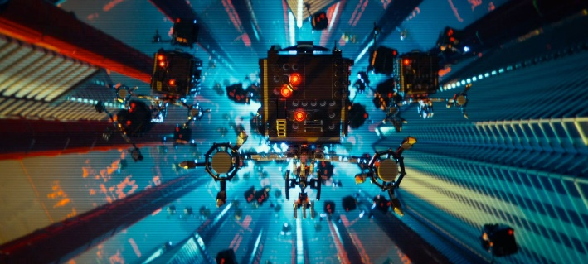**The Plan 2** (1:10:28 – 1:17:41)

With Emmet’s sacrifice, the master builders are saved. They quickly proceed to escape and Benny once again asks the question, “What is the plan?” This time, it is Wild Style who steps up and decides to utilize the people of the LEGO universe to fight off Lord Business. She realized what Emmet had during the fall, that the master builders needed to not only work as a team, but allow everyone to be a part of that team. With that, the people begin to fight back against Lord Business.

**Does it Work?**

The plan 2 gets the movie back onto the prescribed track. It begins exactly when it is projected to and serves as a time when the heroes are at their strongest. This new plan builds upon the ideas laid out previously in the movies and the characters rally after the death. The plan 2 sees a drastic rise in excitement as the odds are evened yet again. Despite the death of their prophet, and the protagonist, the remaining characters appear fit to take on the villain and win the day. This would blend directly into the climax of most other films, but *The LEGO Movie*’s last minute reveal, means that there is a definitive gap at the end of the plan and the beginning of the climax.

**The Climax** (1:17:42 – 1:26:14)

It is at this point in the film when the truth of the entire movie is revealed. The characters, their worlds, and their actions, are being controlled by humans in the real world. There is now a parallel implied story that has been taking course during the movie’s runtime. In this parallel story, a young boy wants to play with the toys purchased from the toy store, but his father views them as a hobby and wants them his way. The characters and their rebellion are merely the actions of a young buy defying his father. The father quickly shows up and starts destroying the boy’s creations. At the same time, the audience sees the characters in the LEGO world being defeated by Lord Business’ troops. Now the final truth is revealed. Emmet is the LEGO embodiment of the son, and Lord Business is the father. Eventually, Emmet is placed back in the fight by the son, and he proceeds to show off his creativity on his way to confront Lord Business. There is then a duality of scenes in which Emmet and the Son convince Lord Business and the father that creativity and friendship is the answer. The father is placated, and thus so is Lord Business.

**Does it Work?**

The climax is drawn out in this film because of the last minute reveal. While the narrative did not require the creation of the “real world” storyline to be conclusive, it is strengthened by its inclusion. The stakes are raised in the end by knowing that not only is the fate of the LEGO world in the balance, but so too is the relationship between a father and son. The protagonist and the villain are now representative of two conflicts. The tension rises as the father is introduced and begins ripping up his son’s creations, but the excitement continues to build exponentially as Emmet struggles to get back into the fight, and eventually confronts Lord Business. Because Emmet is absent for the plan 2, this is where we get to see him at his strongest. Upon returning to the LEGO world, Emmet is fully awakened to his creative side and is thus able to handily defeat any villain that stands in his way. The tension of the dual standoff between the LEGOs and the humans culminating in an alliance on both ends leads into the resolution.

**The Resolution** (1:26:15 – 1:32:21)

Lord Business decides to stand down and even hugs Emmet before his base explodes. On the ground, Emmet’s friends celebrate as their enemies drop from the sky defeated. Emmet and Wild Style finally share the hand holding they have been attempting since the beginning of the film, the glued LEGOs are set free, and the father and son reconcile their differences.

**Does it Work?**

The resolution is quite short in this movie, only six minutes in total length, but everything that needs to be said is said. The villain is defeated, the heroes are reunited, and all is right with the world. On the human end, the father and son now have a stronger relationship, and that promises to lead into bigger, brighter changes within the LEGO world as a result. Without the stinger at the end, the script writers would have needed to draw out the resolution a little because it would have felt overly abrupt, á la the matrix. However, with the stinger, it is perfect in length and serves as a fitting conclusion to the tale.

**The Stinger** (1:32:21 – 1:33:01)

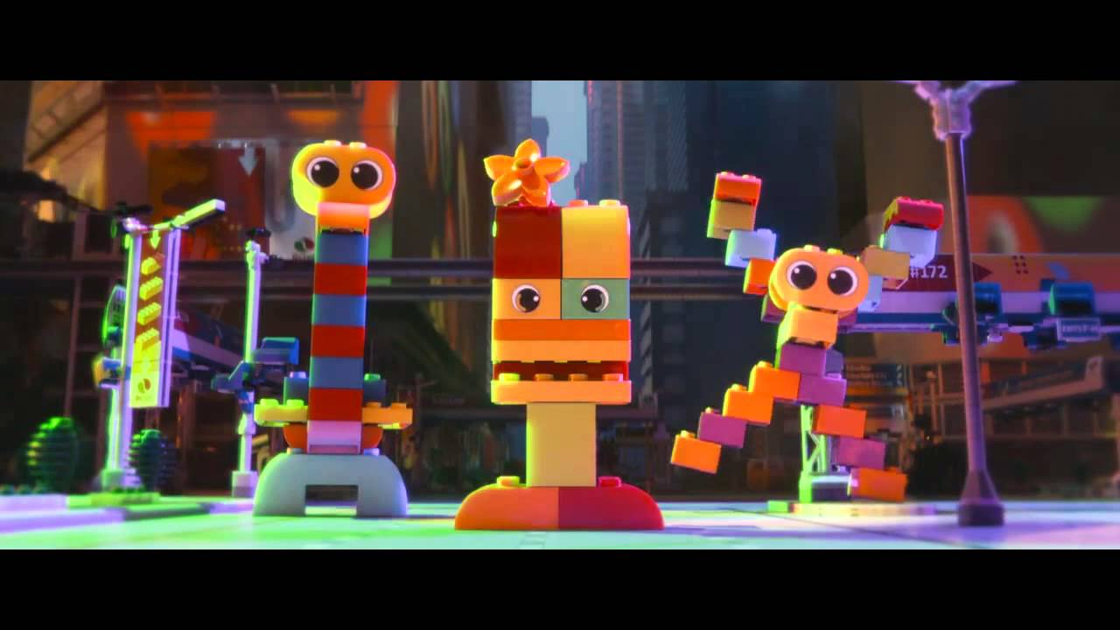 The father reveals to the son that if he is allowed to play with the LEGOs, then so too is his little sister. In the LEGO world, a spaceship appears in the sky and out drops three Duplo characters who reveal that they will destroy the LEGO world. Roll credits.

**Does it Work?**

While lasting less than a second, the stinger perfectly caps off the end of the movie and allowed the writers a shorter resolution. It serves the purpose of a stinger and even has the appearance of one on the beat map. One final spike of excitement and a hint as to what may come in the future is all an audience member can ask for in a stinger and it is delivered well here. It also flows nicely into the credits and gives audience members something to speculate on as they vacate the theater or watch the credits scroll.